North District Open Water Swimming Team in France

Last weekend, a small team representing the North District competed in the French Open Water Cup Final at Jablines, near Paris.

The event attracts the best swimmers from France with a few international entrants. This year the 5 km event also doubled as their national championships. More than 300 competitors were taking part giving the team the opportunity to race against bigger fields than they would meet in the UK. All 7 members of the team competed in the 5 km on Saturday. The following day, three of the team (Fraser Tetlow, Ben McLaughlin and Kelly McIntosh) tackled the grueling 10 km event while the other’s (Catherine Boddie, Oscar Chirnside, James Boddie and Isla Reid) competed over 2.5 km.

Overall, the team won 3 gold and 5 bronze medals with some providing a swimmer with a medal in their age-group as well as the overall competition. Fraser Tetlow won the bronze medal in the 10 km race in the men’s 16-17 year category with Kelly McIntosh gaining the bronze for the women’s 25-44 year masters category. This followed the bronze she won in that category in the 5 km event the previous day.

The 2.5 km race proved to be the best source of medals for the Scots. Catherine Boddie was the overall winner of the women’s event and was awarded another gold as the winner of the 18-19 year category. Oscar Chirnside was third in the overall men’s event which was a remarkable achievement for the 14 year-old. He won the gold medal in his 14-15 year age category with his Garioch clubmate James Boddie taking the bronze.

Team coach Richard McLaughlin said “This has been a fantastic experience for our youngsters. We were really lucky to have Kelly on our team who has competed at several international Open Water events allowing us to draw from her experience. For some James and Isla this was their first 5K and certainly the busiest field that the team have raced in with over 200 competitors taking part. Fraser and Ben were delighted to get a chance to race a 10K as the opportunities at home are few and far between for that distance. The team raced really well and have had lots of learning opportunities which will stand them in good stead for next year’s Open Water season. There is a growing interest in Open Water racing, and I really hope this event will encourage more clubs and swimmers to get involved.”
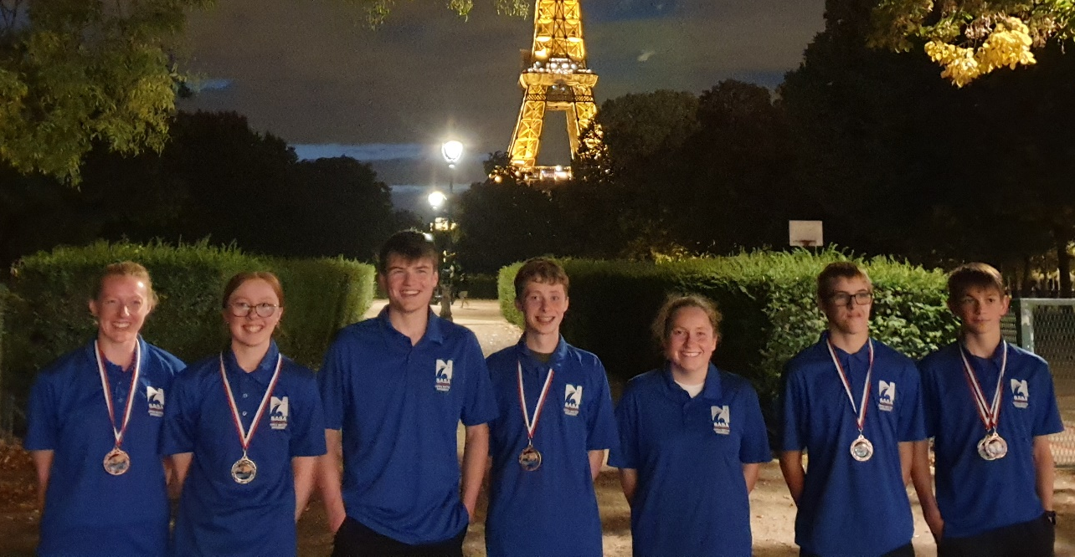
The North District Team (Left to Right: Kelly McIntosh, Catherine Boddie, Ben McLaughlin, James Boddie, Isla Reid, Fraser Tetlow, Oscar Chirnside)

