Important Notes on Results and Ranking Files
For those Clubs running Meets
After your Meet is complete it is important to send the results to British Swimming in order that the times are included on their Rankings database, otherwise swimmers may not be able to enter certain National level Meets or any competition taking place in England. If you are new to this, instructions for creating these "Ranking Files" and where to send them are given at the end of this document.
However, British Rankings are now receiving what they consider to be an unacceptable amount of errors when they import these Ranking Files. Obviously, every error means extra time taken to check and usually they import the correct results and will then send back a list of errors where they cannot match the Ranking files sent to their database. Unless and until you correct these, the swimmer's results will not appear on Rankings. Usually they are either name or date of birth errors and you need to contact the parent Club's entry secretary to identify the swimmer's correct name spelling (remember to check for hyphens, middle initials etc) and date of birth and make sure your Meet Manager database is exactly the same as the Scottish Swimming membership database. Usually if you e-mail Rankings back with the Scottish Swimming ID number they are then able to match the swimmer and rank their results.
We need to minimise these errors as much as possible as they cause a lot of extra work both for Rankings and the person trying to process the results from the Meet ie you and I. A regular audit between Team/Swim Manager and the Scottish Swimming membership database is the best option but British Swimming have also produced some checklist to help with this process. Here are the links to these checking tools, ideally you should run the first one a week or two before the Meet as this then lets you chase up the entering Club for the correct information and avoids any errors reaching the Rankings team.
www.swimmingresults.org > Entry Tools > Entry Check (Hy-Tek)
The second checking tool is designed to check your actual Ranking files for errors.
https://www.swimmingresults.org/mrfresultscheck/
Follow the instructions in the links and if you run these it should further reduce any errors.
Rankings also advise that we use the correct allocated "short name" for our Clubs - some clubs do, some are simple and obvious ie the short name for Aberdeen ASC is Aberdeen but some are less so and some clubs simply use either the 4 digit code or an abbreviation of their Club name ie NSNX or SASC for Stonehaven. The correct club codes are listed below and if all our Clubs entered these as the "short name" in their Team/Swim Manager it would help Rankings and it would also help Announcers as some of the currently used "short names" are not always immediately obvious to them either.
Sorry if this looks like a lot of extra work but if not done correctly then there is a distinct possibility that our swimmers' times will not be ranked, with considerable knock-on effects for future Meets.
Aberdeen Dolphins ASC | NADX | Aberdeen Dol
Aberdeen ASC | NANX | Aberdeen
Alford Otters ASC | NAOX | Alford Otter
Aberdeen University Swimming & Water Polo Club | NAUX | Aberdeen Uni
Aberdeen Diving Club | NAVX | Aberdeen DC
Bon Accord Thistle ASC | NBAX | Bonn Accord
Banchory Beavers ASC | NBBX | Banchory
Bridge of Don ASC | NBDX | Bridge O Don
Broch SC | NBHX | Broch
Buckie ASC | NBKX | Buckie
Banff and Buchan Masters | NBMX | Banff&Buchan
Bucksburn ASC | NBNX | Bucksburn
Cults Otters ASC | NCOX | Cults Otters
Dyce (Aberdeen) ASC | NDAX | Dyce
Delting Dolphins ASC | NDDX | Delting
Deveron ASC | NDNX | Deveron
Dingwall | NDIX | Dingwall
Elgin SC | NENX | Elgin
Forres Blu Fins ASC | NFBX | Forres
Free Style SC | NFSX | Free Style
Garioch ASC | NGHX | Garioch
Grantown-on-Spey SC | NGRX | Grantown
Highland Disability Swim Team | NHDX | Highland Dis
Huntly ASC | NHYX | Huntly
Inverness ASC | NISX | Inverness
Lochaber Leisure Centre Swim Team | NLRX | Lochaber Lei
Lerwick ASC | NLKX | Lerwick
Nairn ASC | NNNX | Nairn
Nairn Synchro SC | NNSX | Nairn Synchr
Orkney ASC | NOYX | Orkney
Peterhead ASC | NPDX | Peterhead
Silver City Blues ASC | NSCX | Silver City
Shetland ASC | NSHX | Shetland
South Mainland ASC | NSMX | South Main
Stonehaven ASC | NSNX | Stonehaven
Tain ASC | NTNX | Tain
Thurso ASC | NTOX | Thurso
University of Aberdeen Performance Swimming | NUAX | Aberdeen Per
Upper Deeside ASC | NUDX | Upper Deesid
Ullapool Swimming Club | NULX | Ullapool SC
Westhill District ASC | NWDX | Westhill
Swim Western Isles | NWIX | Swim W Isles
Wick ASC | NWKX | Wick
Westside Sharks Swimming Club | NWSX | Wside Sharks
Whalsay ASC | NWYX | Whalsay
Ythan ASC | NYNX | Ythan
Highland Swim Team | UHIX | Highland
South Aberdeenshire Swim Team | USAX | South Aberde

Here are step by step instructions on how to create the necessary reports from Meet Manager.
For the British Swimming Ranking files go to Reports:- Results:- Columns Format:- Select British Rankings as shown
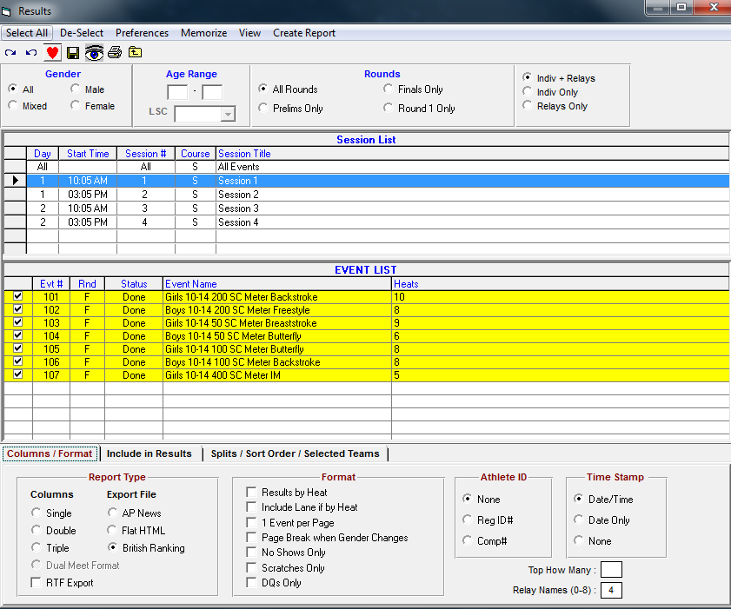
Then click Create Report and the following screen will appear. Take note of where it has sent the files. Each session has to be done separately for these so do them all and then attach them to your e-mail along with a complete set of results in word format as required by British Swimming. I use the rtf option when exporting these and include the Licence number of the Meet on the document.
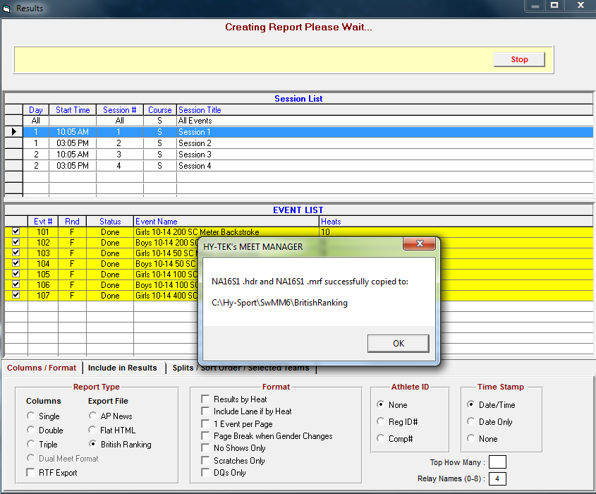
These should then be e-mailed to: rankings@swimming.org if your Meet was accredited.

Here also are notes on how to create the Meet results documents and results file if required.

PRODUCING THE MEET RESULTS DOCUMENT
To produce the Meet Results:-
Click on the Reports menu on the Run screen, or click on Reports on the Main Menu Bar.
Select the Results option.
In the Session List, click on All to display all events in the meet.
Click on the Select All icon , or click on the Select All option on the menu.
The format of the report can be amended using the options on the Columns/Format tab. The standard is Double columns.
You can customise the information contained in the report on the Include in Results tab e.g. to show Records in the report click on the Records check box.
You can specify which, if any, splits you wish printed on the report by making the appropriate selection on the Splits / Sort Order / Selected Teams tab.
Click on the Create Report menu option to produce the report and hand to the Referee for signing.
You may also be responsible for sending out the Results file to the participating clubs and Ranking files for British Swimming .
To create the Results file go to File:- Export:- click on Results for Swim Manager etc -

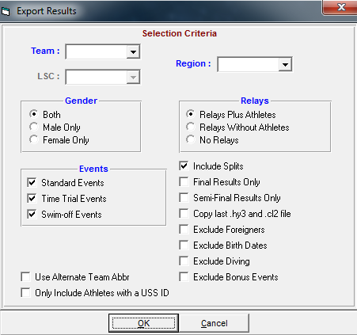

Click on OK and it will run through the Teams and Athletes for the results, then it will ask where to save the file:-

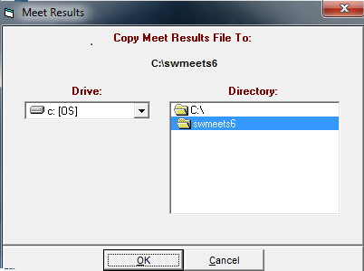
Either go with the default option or choose another, usually a USB stick. The results file should be sent to Scottish Swimming for inclusion in their database which they use to identify swimmers for National Squads including the DRP.
Only send if your Meet was accredited, e-mail to s.mccallum@scottishswimming.com

