ELGIN ASC ‘NEARLY’ SPRING’ MEET
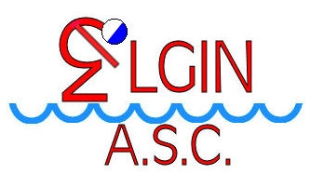
Saturday/Sunday 17th & 18th February 2024
Buckie Leisure Centre, South Pringle Street, Buckie, AB56 1PX
CLOSING DATE FOR ENTRIES, SUMMARY SHEET & FEES:
MIDNIGHT – FRIDAY 26th January 2024
Summary Sheet
Club Name/Abbr: | Meet Secretary:
 | Address:
Tel No:
Email:

 | Ind 50m/100m/200m Male Entries | @ £7.00 | £
 | Ind 50m/100m/200m Female Entries | @ £7.00 | £
 |  | Total: | £
Paperwork and Payment must be received within 3 postal days of closing date:
Have you sent: Hytek TM Entry Zip File, Summary Sheet, BACS.

Payment Via: BACS Account No: TSB Elgin A/C 00030028 Sort Code: 30-25-89.
Payment Reference ELSM24 followed by Club Code eg ELSM24NENX.

In case of Refunds – please supply the following information:
Bank Account Number: …………………………………………….. Sort Code: ……………………
Bank Account Name: …………………………………………………

Declaration: I confirm that all swimmers entered in this competition have paid their current SASA membership fee.
I confirm that all coaches and/or team staff from our club who will be on poolside are members of Scottish Swimming and have current PVG disclosure.
Signed: ............................................ Position in Club: ..................................... Date: .............................
(This declaration must be completed by all competing clubs)

L2/ND/013/JAN24

